 | United International University  Summer 2026, Introduction to Computer Systems: CSE 1110 Problem Set (Beginner to Advanced)  Prepared by: Azizur Rahman Anik, Lecturer
Beginner Level (Warmup)
1.​Write a C program that accepts two integers from the user and calculates the product of the two integers.
2.​Write a C program that accepts an employee's ID, total worked hours in a month and the amount he received per hour. Print the ID and salary
3.​Write a C program to calculate the distance between two points.
4.​Write a C program to find if an integer is even or odd.
5.​Write a C program to check if an integer is positive, negative or zero.
6.​Write a C program where the user will give his marks (ranging from 0 to 100.0) as input and you will calculate his grade based on your university grading system and show it as output.
7.​Write a C program to check if a character is alphabet, numeric or special character.
8.​Write a C program that reads three floating-point values and checks if it is possible to make a triangle with them. Determine the perimeter of the triangle if the given values are valid.
9.​Write a C program that reads an integer between 1 and 12 and prints the month of the year in English.
10.​Write a C program to accept a coordinate point in an XY coordinate system and determine in which quadrant the coordinate point lies.
Intermediate Level
11.​Write a C program to find the largest of three numbers.
12.​Write a C program that reads 5 numbers and counts the number of positive numbers and negative numbers.
13.​Write a C program that accepts some integers from the user and finds the highest value and the input position.
14.​Write a C program to find whether a given year is a leap year or not.
15.​Write a C program to calculate the root of a quadratic equation.
16.​Write a C program to read temperature in centigrade and display a suitable message according to the temperature state below:
Temp < 0 then Freezing weather
Temp 0-10 then Very Cold weather
Temp 10-20 then Cold weather
Temp 20-30 then Normal in Temp
Temp 30-40 then Its Hot
Temp >=40 then Its Very Hot
17.​Write a C program to check whether a triangle is Equilateral, Isosceles or Scalene.

18.​Write a program in C to calculate and print the electricity bill of a given customer. The customer ID, name, and unit consumed by the user should be captured from the keyboard to display the total amount to be paid to the customer.​
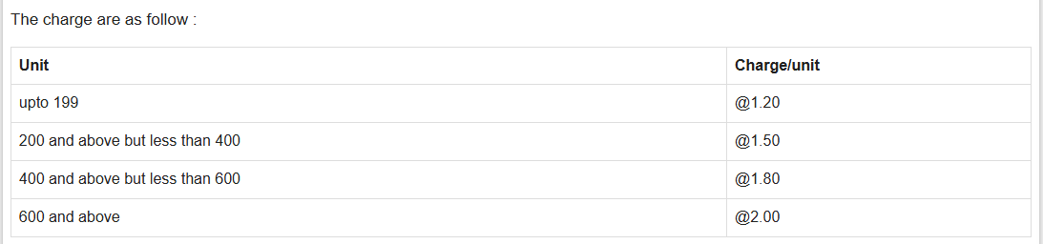
19.​Write a C program to take input n numbers from the user and find the sum of those n numbers.
20.​Write a C program to display the n terms of odd natural numbers and their sum. 21.​Write a C program to calculate the factorial of a given number.
22.​Write a program in C to display the n terms of a harmonic series and their sum.
23.​1 + 1/2 + 1/3 + 1/4 + 1/5 ... 1/n terms
24.​Write a program in C to find the sum of the series [ x - x^3 + x^5 + ......].
25.​Write a C program that displays the n terms of square natural numbers and their sum. 26.​Swap the values of two variables using a third variable.
27.​Swap the values of two variables without using a third variable.
28.​Find the maximum and minimum of n numbers given by the user.
29.​Read a positive integer and print the sum of its digits.
30.​Read an integer and decide whether it is prime or not.
31.​Write a C program to find the factors of a given number.
32.​Write a program in C to display a given number in reverse order.
33.​Write a C program to check whether a number is a palindrome or not.
Semi-Advanced Level
1.​Write a program in C to find the number and sum of all integers between 100 and 200 which are divisible by 9.
2.​Write a C program to check whether a given number is a 'Perfect' number or not. 3.​Write a C program to check whether a given number is an Armstrong number or not. 4.​Write a program in C to display the first n terms of the Fibonacci series.
5.​Write a C program to find the second largest number from n input numbers.
6.​Write a C program where users give n-1 natural numbers ranging from 1 to n as input where the user does not repeat a number. You need to find out the missing number within the range 1 to n.

7.​You are given three digits a, b, c. Two of them are equal, but the third one is different from the other two.
8.​Find the Greatest Common Divisor (GCD) of two numbers. 9.​Find the Lowest Common Multiple (LCM) of two numbers.
Advanced Level (For Starting Your Journey as a Contest Programmer)
1.​Write a program in C to check whether a number can be expressed as the sum of two primes.
2.​Write a C program to check whether a given number is ugly or not. An ugly number is a positive integer whose only prime factors are 2, 3, and 5.
3.​You are given two integers a and b. In one move, you can choose some integer k from 1 to 10 and add it to a or subtract it from a. In other words, you choose an integer k∈[1;10] and perform a:=a+k or a:=a−k. You may use different values of k in different moves. Your task is to find the minimum number of moves required to obtain b from a.
4.​In this problem you are to calculate the sum of all integers from 1 to n, but you should take all powers of two with minus in the sum. For example, for n = 4 the sum is equal to - 1 - 2 + 3 - 4 = - 4, because 1, 2 and 4 are 20, 21 and 22 respectively.
5.​Polycarpus adores TV series. Right now he is ready to finish watching a season of a popular sitcom "Graph Theory". In total, the season has n episodes, numbered with integers from 1 to n. Polycarpus watches episodes not one by one but in a random order. He has already watched all the episodes except for one. Which episode has Polycaprus forgotten to watch?​
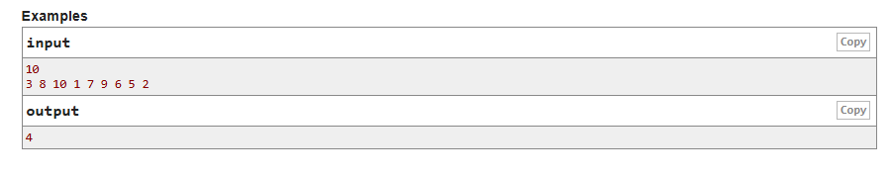
6.​
7.​​
8.​​
9.​
10.​​ | ​ | ​

